*Umadevi Areekkara Kizhakkemana*

*Student ID: 10592856*

7135CEM - Modelling and Optimization Under Uncertainty

Coursework

Part 1

Topic Modelling and Sentiment Analysis on Climate Tweets

Abstract:

This paper focuses on comparing multiple topic modelling techniques on climate related tweets. Topic modelling techniques like Latent Dirichlet Allocation (LDA), Latent Semantic Analysis (LSA) and Non-negative Matrix Factorization (NMF) are explored here. Since the dataset contains sentiment score from trusted reviewers, general sentiment analysis also carried out as part of this study to analyze what the world is thinking about the climate change. The main idea of this work is to apply different topic modeling algorithms on the same corpus and compare the behavioral difference between each of them.

Introduction:

As per United Nations, climate change can be considered as the shift in weather and temperature patterns. This shift can be natural or man-made [1]. From last few decades the effect of human activities on the earth impacts its climate balance and resulted in sudden climate changes. Climate change has become one of the most concerning global challenge for the society [2]. The consequences include water scarcity, draughts, forest fires, polar ice melts, raising sea level and may more. Scientists and ordinary people have different opinion on the climate change issues. Many think that human should avoid or reduce the activities like burning fuels, plastic usage etc. They pointed out the reduced pollution rate in the pandemic time as the main evidence for that since during the pandemic time, vehicle usage was less. Still, many others think that even though human reduce these kind of activities, climate change is an inevitable phenomena that will happen as per the long historic trends [3]. Many think that a volcanic eruption may contribute more adverse to the global warming than any human activities. Thus, people around the world have different viewpoints on climate changes. The main aim of this coursework is to understand ‘what people are thinking about climate change’ by analyzing recent climate related tweets. Upsurge in the usage of social media enabled a new opportunity to collect public opinion without directly do a survey. Tweeter is one of the most influencing and effective source in that kind.

Much research has been done so far on the basis of the tweeter data in public domain to analyze climate related issues. Few of them incorporated efficient topic modelling techniques also as part of their research. One of the predominate and recent one is the study of *Gaytan et al* in 2021. They analyzed the tweeter data collected using recurrent neural networks (RNN) and unsupervised learning Latent Dirichlet Allocation (LDA) topic modelling, to understand the actions to be taken to tackle climate change related issues [2]. Another recent research conducted by *Yasin et al* in 2020 was about thesentiment analysis of tweets on global warming. In their research paper, it mentioned the linear and probabilistic classifier methods for efficient sentiment analysis on text data [4]. ‘Text Mining of Twitter Data Using a Latent Dirichlet Allocation Topic Model and Sentiment Analysis’ by *Sidi et al* is another vital study on the topic model application on tweeter data. In this study, they explored text mining using LDA topic modelling and Sentiment analysis. It helped them to give insight views in business and scientific fields in Canada [5]. A much important study in this field is conducted by *Salvatore et al* in 2020. Their paper explores the nature of topics posted by public on Twitter during world Lupus Day to extract latent topics that occur in tweets and to identify what information is most discussed among them [6]. They succeeded in identifying the hidden information about the healthcare system by revelling the disagreement between the topics discussed by influencers on the same issue [6].

In this coursework, exploring the possibilities of LDA, LSA and NMF on recent climate tweets.

Dataset:

Recent climate tweets collected from a public data source (Kaggle). This data set contains nearly 50,000 tweets pertaining to climate change collected between 2018 and 2021. Each tweet is labelled as one of the following classes:

2 (News): The tweet links to factual news about climate change

1 (Pro): The tweet supports the belief of man-made climate change

0 (Neutral): The tweet neither supports nor refutes the belief of man-made climate change

-1 (Anti): The tweet does not believe in man-made climate change

The problem here is to identify the important topics that public broadcast about the climate change related issues. The results give a general awareness among the public regarding the discussions. Similarly, it will help the government authorities to gather public opinion and act accordingly.

Methodology:

Three different topic modelling techniques are applied in this course work. Latent Dirichlet Allocation (LDA), Latent Semantic Analysis (LSA) and Non-negative Matrix Factorization (NMF). Sentiment analysis based on the sentiment score available also tried out.

Topic modelling techniques are built on the assumption that each document is a mixture of topics, and each topic is a collection of words. The idea here is to identify the latent (hidden) topics in each document.

*Fig 1: Topic Modelling --- source google images*

Latent Semantic Analysis (LSA):

LSA is one of the fundamental topic modelling technique. The entire corpus divides into document-topic matrix and topic-term matrix. The main idea is to create an inverted index kind of matrix with rows represents each document and columns represents tf-idf values of each word in the vocabulary. Tf-Idf (term frequency – inverse document frequency) values determine the significance of words in each document. Since the document – term matrix is very diverse and sparse, applies dimensionality reduction methods to retrieve most relevant information. Generally Truncated SVD technique is used in LSA [7]. Truncated SVD reduces dimensionality by choosing only the ‘t’ largest singular values, and only keeping the first ‘t’ columns of document-term and topic-term matrixes [7]. Once the document vector and term vector are created, significance of a topic to a document is calculated based on the cosine similarity method.

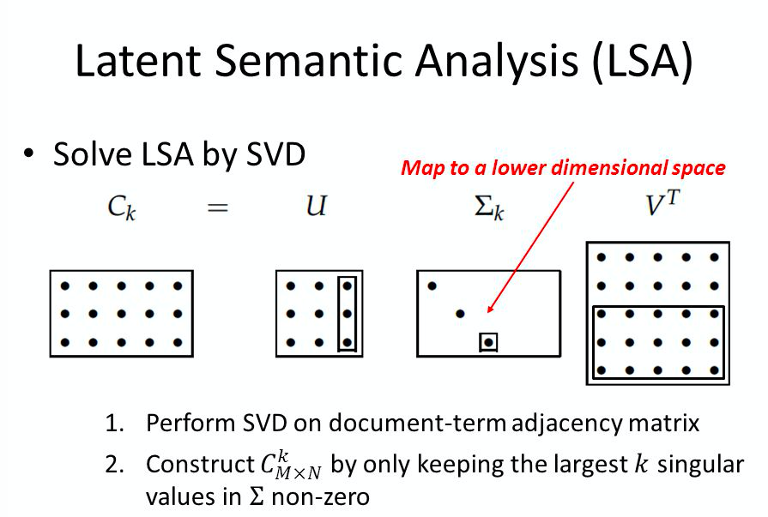

*Fig 2: LSA representation --- source https://slideplayer.com/slide/7887302*

Latent Dirichlet Allocation (LDA):

Latent Dirichlet Allocation is another commonly used topic modelling technique. It a bit advanced than LSA and considered as a Bayesian version of probabilistic latent sentiment analysis (PLSA) [8]. PLSA works on a probabilistic method than the truncated SVD version in LSA. We may consider the term Dirichlet as a distribution over distribution. It provides a way of sampling probability distributions of a specific type [8].

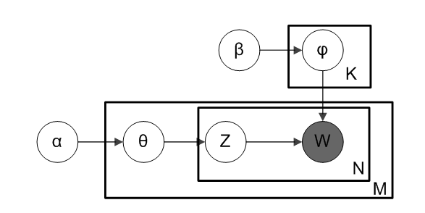

*Fig 3: LDA Model --- source [7]*

In the above figure, α and 𝛽 are two dirichlet distributions corresponding to topics and words. From α, selects a random sample to represent topic distribution (θ) and then select a specific topic z based on the distribution. Similarly, from 𝛽, selects a random sample representing the word distribution (φ) and from φ, choose a word w.

The process can be summarized mathematically as shown below

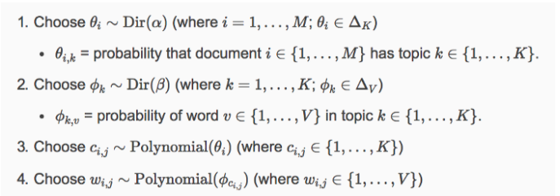

*Fig 4: LDA process --- source https://cs.stanford.edu/~ppasupat/a9online/1140.html*

Non-negative Matrix Factorization (NMF):

Non-negative Matrix Factorization has become a popular tool in high dimensional data analysis as it automatically extracts the meaningful feature from noncognitive data vectors [9]. NMF identifies topics in a set of documents and simultaneously classify the documents according to the topics.

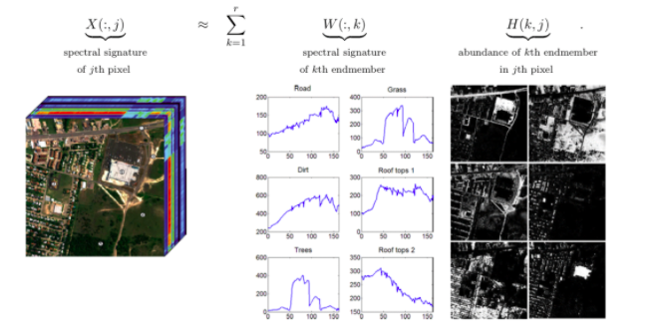

*Fig 5: NMF process representation --source [9] and* [*http://www.agc.army.mil/*](http://www.agc.army.mil/)

One of the major issue with NMF is that it may end up with too many schemes for defining a basic element. In the case of text mining, it may produce multiple topics for a single document. This problem can be tackled by adding proper regularization terms in objective function [9].

Sentiment Analysis:

Sentiment analysis is popular text classification method, which analyses the text data and classify them as positive, negative or neutral based on the underlying sentiment. Sentiment analysis plays a major role in taking decisions in every sector. Customer review analysis in e-commerce sector, public opinion analysis in election campaigns etc. are powerful examples for the relevance of sentiment analysis in today’s market.

Experimental setup and Results:

The experiment is carried out in MacBook Air, 1.6 GHz Intel Core i5 and 8GB memory. Programming code for running the process is done in Python language using Jupyter Notebook IDE. Python code is referred from multiple Kaggle documents and topic modelling documents like [10] and modified as per the dataset and problem.

1. Exploratory Data Analysis

Analyzing the source data carefully helps to understand the data thoroughly and model them properly. In this step, combined the data collected from multiple sources into a single csv file. Loaded the data into a data frame object for further analysis. Imported required python libraries for program.

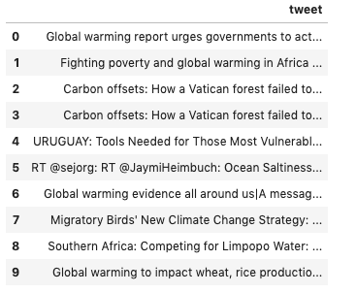

*Fig 5: Sample tweets from the dataset*

Since the dataset is a collection of tweets, identifying popular tweets would help to identify what most of the people are tweeting about. Some of the tweets here are retweets. That also identified with the keyword ‘RT’ in the message.

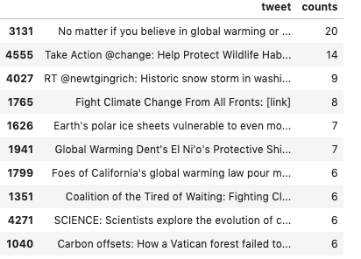

*Fig 6: Most popular tweets*

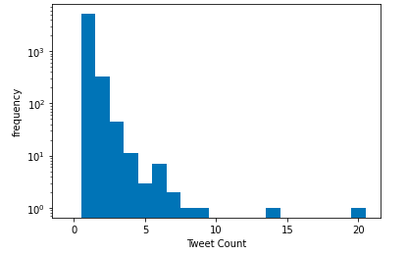

*Fig 7: Tweet frequency*

Identified few frequent hashtags in the tweets by taking the words coming after ‘#’ symbol in the texts.

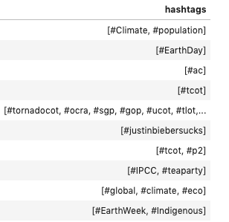

*Fig 8: Frequent hash tags*

1. Sentiment Analysis

The selected dataset contains sentiment score from trusted reviewers.

-1: "Anti",

0: "Neutral",

1: "Pro",

2: "News"

Detailed analysis the sentiment values would give an overall idea about how people are thinking about the situations. From the analysis it is found that 52% of tweets tagged as ‘ Anti’, means 52% of the population thinks that the climate change is not man made. 18% people thinks that its man-made and 21% people are neutral on this issue. We have few percentage of tweets about the news containing climate changes.

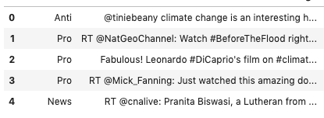 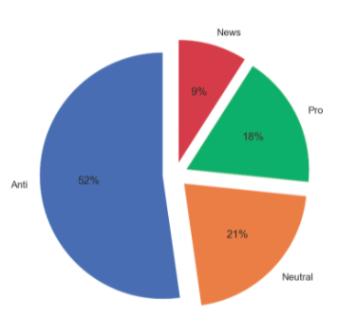

*Fig 9: sample tweets with sentiment values Fig 10: Tweet Distribution*

Below word clouds represents frequent words in each sentiment category.

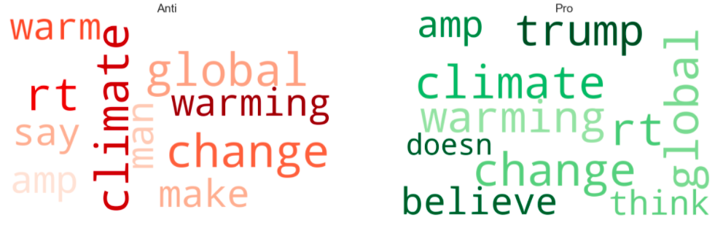

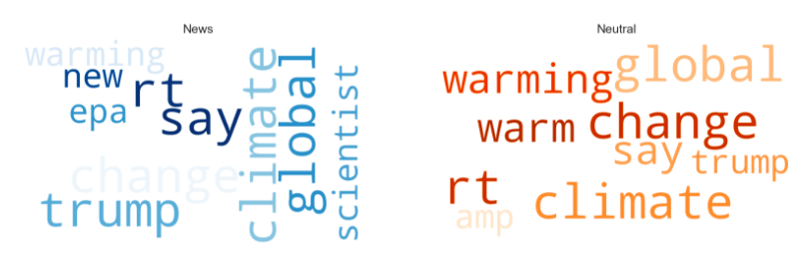

*Fig 11: Word Cloud for each sentiment category*

From the word cloud results, it is difficult to conclude on the people’s sentiment on the climate change issue. Still, as an overall, according to the given dataset, majority of the people are thinking that the climate change is not only a man-maid phenomena but there are many other factors influencing the climate change.

1. Data Preprocessing

Handling unstructured data is the main challenge in any data mining process. The tweets have to be cleaned up for the modelling purposes. Tweets are manually entered comments. It may contain non-English characters, unnecessary punctions, emotions etc. Need to massage the tweets by removing all unnecessary entries to make them more unified and standardized format. That will help to improve the efficiency of the model.

As part of the preprocessing, removed the links available in the tweets and stripped out the users (‘@user’) from tweet’s body. Removed stop words, stemming words and punctuation characters to maintain only topic relevant words. The entire corpus is converted into lower case to avoid double counting while calculating tf-idf values.

Once the cleaned data is ready, next step is to convert the text into vector form for the modelling purposes. CountVectorizer from sklearn libraries is used in this work to convert the text documents into vector form.

1. Applying Topic Modelling

Have tried out 3 different topic modelling techniques in this coursework. LSA, LDA and NMF. Have used sklearn libraries for all three. The vectorized clean data passed through each model and checked the topic listings. Have considered number of topics as 10 for each of them for the result comparison purposes.

For LSA, TruncatedSVD imported from sklearn decomposition module, and defined the model with 10 topics (components), 10 iterations and algorithm to be considered for dimensionality reduction as ‘randomized’. Model fitted for the vectorized cleaned tweets and displayed the topics for further comparison with other models.

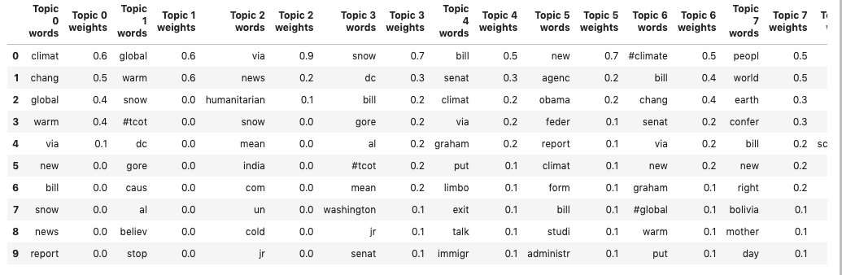

*Fig 12: Topic Listing of LSA*

Similar to LSA, for LDA also the LatentDirichletAllocation algorithm imported from skleran decomposition module and defined the model with number of topics as 10 and random state as 0. Fitted the model for the cleaned tweet vectors (term-frequency vectors) and displayed the topic predictions for further comparison with other models.

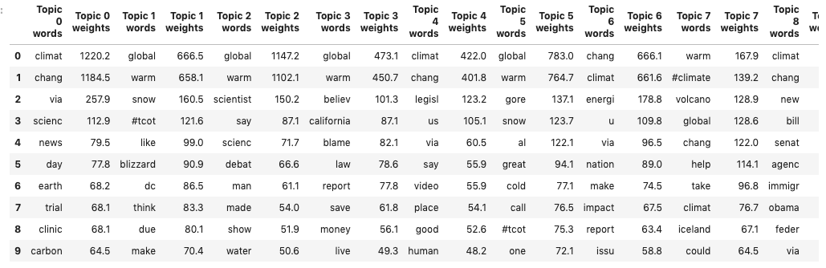

*Fig 13: Topic Listing of LDA*

The NMF algorithm also imported from sklearn decomposition model. Model defines with parameters like number of components (topics) as 10, random state 0, alpha (regularization term) as 0.1 and li_ratio (regularization mixing parameter) as 0.5. Model fitted for the cleaned tweets vectors and displayed the topic predictions for further comparison with other models.

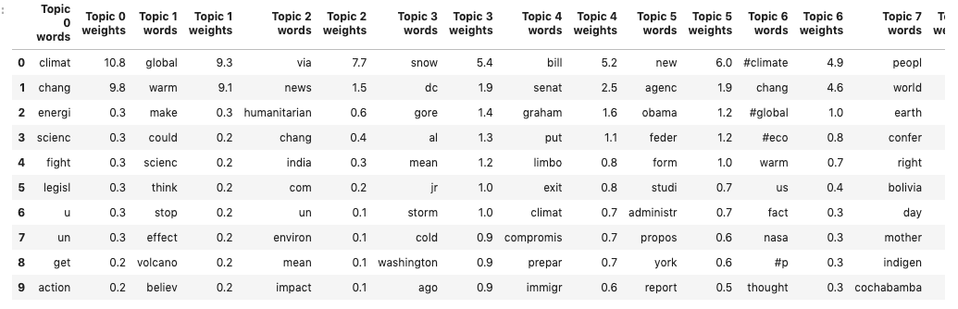

*Fig 14: Topic Listing of NMF*

From the above results it’s clear that the topics were almost similar for LDA and LSA models, whereas the topic allocation of NMF is slightly different. Both LDA and LSA captured all relevant and important words and clustered into different topics. Below is the word cloud of Topic 2 of LDA and topic 1 of LSA. Both look almost similar. That shows that both models captured relevant words into topics.

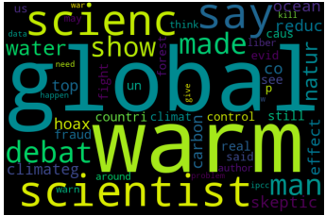 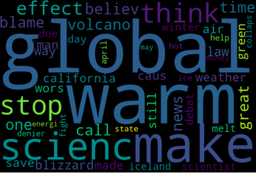

*Fig 15: Word cloud of topic 2 of LDA Fig 16: Word cloud of topic 1 of LDA*

Perplexity of LDA model:

Perplexity is a statistical measure which define how well a probability model predicts a sample. When applying to LDA context, perplexity shows how well the model generates topics. Lesser the perplexity, more similar the words in a topic. Below is the perplexity – Topic number plot which shows the perplexity variation for a range of topics.

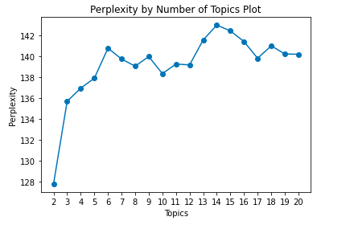

*Fig 17: Perplexity plot*

From the above graph, we can see that the perplexity is less for topics till 5. And then for number of topics = 10 also it is reducing a bit. Further to 10, the perplexity score is increasing. So, we may say that for maximum 10 number of topics, the model would give good results.

Social, ethical, legal and professional considerations

Data for this work is collected from public websites like Kaggle (<https://www.kaggle.com/edqian/twitter-climate-change-sentiment-dataset>, <https://www.kaggle.com/joseguzman/climate-sentiment-in-twitter>) and data.world (<https://data.world/crowdflower/sentiment-of-climate-change>), have not breech any security concerns on the sites. Code, materials and other referred items are clearly cited in the reference session to avoid any legal and ethical policy violations.

Discussions and Conclusion

Climate change is a global issue that is very much visible recently. There are multiple campaigns happening around the world to make people aware about the consequences and encourage them to do at least baby steps to tackle the problem. Twitter has become one of the easily accessible broadcasting platforms nowadays and people started sharing their opinions through this medium. Thus, analysing twitter data helped to uncover hidden information.

The topic modelling techniques applied here in this coursework was very successful in identifying relevant topics in the selected twitter text. Even though the sentiment analysis results that majority of the people believes that the climate change is not merely man-made, but it is natural triggered too, from the topic modelling results we may see that many are worried about climate change issues like global warming. Terms like Global, Warming, snow, fire, volcano etc. in the top list of topics emphasise the significance of those words in the tweets. Both LDA and LSA behaved similarly to the climate dataset. Whereas NFM failed to capture the most significant terms in the document as per the results.

In conclusion, text mining techniques like topic modelling is very useful in current world scenario to understand people’s voice on any issues. With the help of advanced machine learning techniques, we may tackle out any complex problems that earlier we couldn’t think of.

References:

1. United Nations, Climate Action, an article about climate change in UN website, <https://www.un.org/en/climatechange/what-is-climate-change>
2. Gaytan Camarillo M, Ferguson E, Ljevar V, Spence A. Big Changes Start With Small Talk: Twitter and Climate Change in Times of Coronavirus Pandemic. *Front Psychol*. 2021;12:661395. Published 2021 Jun 15. doi:10.3389/fpsyg.2021.661395
3. Mann M.E. (2009) Climate Variability and Change, Last 1,000 Years. In: Gornitz V. (eds) Encyclopedia of Paleoclimatology and Ancient Environments. Encyclopedia of Earth Sciences Series. Springer, Dordrecht. https://doi.org/10.1007/978-1-4020-4411-3_42
4. Yasin Kirelli, Seher Arslankaya, "Sentiment Analysis of Shared Tweets on Global Warming on Twitter with Data Mining Methods: A Case Study on Turkish Language", Computational Intelligence and Neuroscience, vol. 2020, Article ID 1904172, 9 pages, 2020. <https://doi.org/10.1155/2020/1904172>
5. Sidi Yang, Haiyi Zhang, Text Mining of Twitter Data Using a Latent Dirichlet Allocation Topic Model and Sentiment Analysis, World Academy of Science, Engineering and Technology International Journal of Computer and Information Engineering Vol:12, No:7, 2018
6. Salvatore Pirri, Valentina Lorenzoni , Gianni Andreozzi, Marta Mosca and Giuseppe Turchetti, Topic Modeling and User Network Analysis on Twitter during World Lupus Awareness Day, International Journal of Enviornmental Research and Public Health, Jul 2020
7. Joyce Xu, Topic Modeling with LSA, PLSA, LDA & lda2Vec, an article in deep learning category of medium.com, May 2018
8. Ria kulshetra, A Beginner’s Guide to Latent Dirichlet Allocation (LDA), an article in towards data science forum, Jul 2019.
9. Adrian Colyer, The why and how of nonnegative matrix factorization, a random walk through Computer Science research, Feb 2018
10. James, Topic Modelling in Python, an article in Coding Club

Appendix:

Source code: <https://github.com/Umadeviak/7135CEM-Coursework-SourceCode>

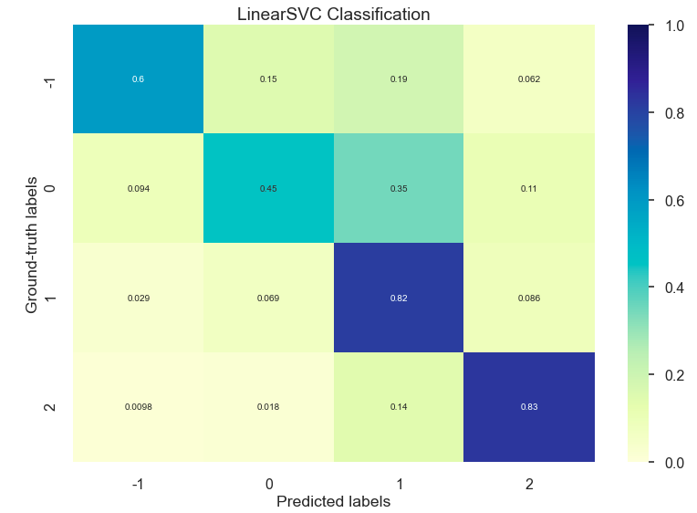

*Fig 18: Confusion Matrix of Support Vector Machine on the sentiment data*

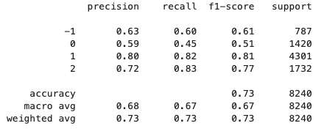

*Fig 19: Classification report of support vector machine*

Task 2

Part 1 - Fuzzy Controller System for a Smart Home

Introduction:

As per United Nations (UN) data of world population prospects, for the first time in history, population aged 65 or above outnumbered children under 5 years globally [1][2]. Elderly population welfare is considered to be the responsibility of the state as well as each individual person. This is always a great challenge as they would need support for even their day-to-day routines. The upsurge in technologies enabled verities of possibilities in health care domain for elderly support. European Framework Program has introduced the term ‘Ambient Assisted Living (AAL)’ for their research funding programs. AAL system improves the quality of life of special group of people including elderly and disabled [3]. The main goal of AAL system is to ensure person’s welfare, that is, monitor illnesses, control the provision of fresh food, generate alerts for medical personnel in case of falls or abnormal situations, monitor medication reminders, and enhance social relations by enabling people-to-people communications [3]. Much research is going on in developing smart devices to enable the AAL in more efficient way.

In this coursework, exploring the features and possibilities of Fuzzy Logic Interface to design a home with smart devices for disabled or elderly residence. Fuzzy control system is a mathematical system that analyzes analog input values in terms of logical variables with continuous values in between 0 and 1. The concepts cannot be expressed as true or false, but rather express as partially true or a specific percentage of trueness [4]. Fuzzy logic tries to look at mathematical problems in a way how human brain thinks with uncertainties and vagueness. Ideally a Fuzzy Inference System (FIS) consist of Inputs, Membership functions, Outputs and Rules. Below image shows the Block diagram of fuzzy logic implementation.

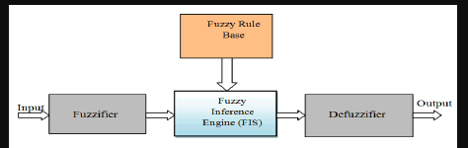

*Fig 1: FIS System -----source [6]*

Fuzzier gets the inputs along with its membership function. FIS engine analyzes the inputs and the rules (how the inputs affect outputs). Defuzzification step incorporates the results from FIS engine along with the output variables with corresponding membership functions.

In this coursework, fuzzy logic controller for a smart home is designed in MATLAB. There are many smart devices in current market as part of AAL care. Considered only few of those essential devices in this work. Heater and Automatic Lamps are considered for overall home. Smoke Detector and Smart Oven are designed as the kitchen specific devices. Water Flow Detector and Water Boiler are for bathrooms. Bed Occupancy Detector and Automatic Bed Lamp are for bedroom specifications. TV Ear should be set up adjacent to TV, ideally for living room set ups. And finally, the Corporal sensor is designed as personal care, like to detect a person is ill or not.

The below table is a list of outputs of the FIS system and their corresponding inputs.

|  |  |  |
| --- | --- | --- |
|  | Output | Input |
| 1 | Heater | Room Temperature |
| Humidity |
| 2 | Automatic Lamp | Light |
| Presence of Person |
| 3 | Water Boiler | Room Temperature |
| Water Temperature |
| 4 | Smoke Detector | Presence of Smoke |
| 5 | Water Flow Detector | Moisture |
| 6 | Corporal Sensor | Blood Pressure |
| Heart Rate |
| Body Temperature |
| 7 | Bed Occupancy Detector | Bed Surface Pressure |
| Time Delay |
| 8 | Automatic Bed Lamp | Light |
| Bed Surface Pressure |
| 9 | TV EAR | Surrounding Volume |
| 10 | Smart Oven | Type of Food |
| Quantity of Food |

*Table 1: Output/Input list*

Methodology:

There are two different fuzzy systems available, Mamdani and Sugeno. Mamdani fuzzy system is used in this coursework. There are mainly 3 main steps/components in Mamdani framework.

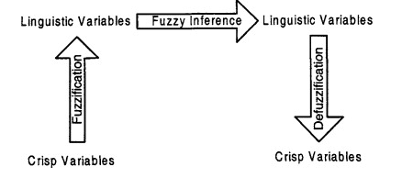*source ‘Science Direct – Electrical Load Forecasting 2010’*

1. Fuzzification

Here the crisp input values would be converting into fuzzy linguistic values based on the prior expert knowledge.

1. Fuzzy Inference

In this step, the fuzzy inputs map to the fuzzy outputs. The mapping is done by a set of rules. Rules, based on multiple input variables can be combined using AND (t-norms)/OR (t-conorms) logical operators. All the defined rules will be clipped and aggregated to obtain the specific result set.

1. Defuzzification

Defuzzification is the process of converting the fuzzy output set into a crisp output value, based on the membership function defined. In this coursework ‘centroid’ method is used for defuzzification.

The first step in any fuzzy controller design is the design of input variables and their membership functions. Trapezoidal and triangular membership functions are used in this work.

Input Variables and Membership Functions:

1. Room Temperature

Temperature control is essential for any home. Have considered a UK home for this course work. So, the temperature range is considered in between -20 to 40 degree Celsius. In fuzzy system its divided into 5 different values. VL (Very Low), L (Low), M (Medium), H (High) and VH (Very High). VL and VH are trapezoidal function and rest are triangular. Below is the membership function for room temperature and value range is displayed in the table.

|  |  |  |
| --- | --- | --- |
| Membership Function | Range (℃) | Type |
| VL | -20 to -10 | Trapezoid |
| L | -15 to 10 | Triangle |
| M | -5 to 25 | Triangle |
| H | 10 to 35 | Triangle |
| VH | 27 to 40 | Trapezoid |
| *Table 2: Details of Room Temperature MF* | | |

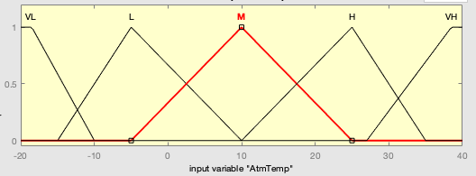

*Fig 2: Membership function for Room Temperature*

1. Humidity

To maintain a balanced temperature inside home, humidity also considered as considering factor. The range is given from 0 to 100 %. Membership function divided into 5 values VL, L, M, H and VH as shown in table 3 and Fig 2.

|  |  |  |
| --- | --- | --- |
| Membership Function | Range (%) | Type |
| VL | 0 to 20 | Trapezoid |
| L | 10 to 40 | Triangle |
| M | 25 to 75 | Triangle |
| H | 50 to 90 | Triangle |
| VH | 70 to 100 | Trapezoid |
| *Table 3: Details of Humidity MF* | | |

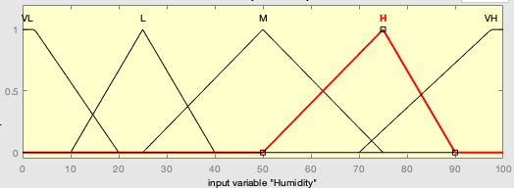

*Fig 3: Membership function for Humidity*

1. Light

The day light is considered as one of the important factor for controlling automatic lamps in the house. The value ranges in between 0 to 20,000 Lux and the membership function divided into 5 different category as shown below.

|  |  |  |
| --- | --- | --- |
| Membership Function | Range (Lux) | Type |
| VL | 0 to 4000 | Trapezoid |
| L | 2000 to 8000 | Triangle |
| M | 4500 to 12000 | Triangle |
| H | 10000 to 16000 | Triangle |
| VH | 16000 to 20000 | Trapezoid |
| *Table 4: Details of Light MF* | | |

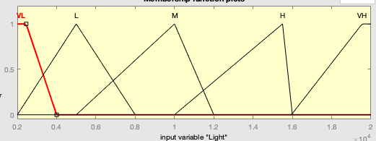

*Fig 4: Membership function for Light*

1. Body Temperature

Checking body temperature is critical for maintaining well balanced health conditions for elderly people and disable people. Alerting regular changes from the normal accepted range avoids unnecessary emergencies. Body temperature range is considered as 10 to 40 degree Celsius and divided into 5 different membership value ranges.

|  |  |  |
| --- | --- | --- |
| Membership Function | Range (℃) | Type |
| VL | 10 to 15 | Trapezoid |
| L | 12 to 25 | Triangle |
| M | 18 to 32 | Triangle |
| H | 25 to 38 | Triangle |
| VH | 36 to 40 | Trapezoid |
| *Table 5: Details of Body Temperature MF* | | |

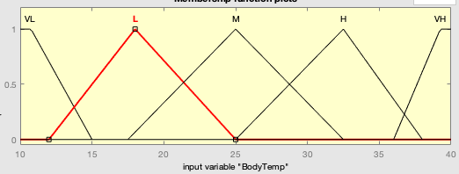

*Fig 5: Membership function for Body Temperature*

1. Blood Pressure

Blood pressure variations are common in elderly population and its highly risky too. Regular checks on blood pressure and alerting the same is essential. The blood pressure value range is considered between 70 to 140 mmHg and divided into 3 membership functions, L, N and H as shown in the below table.

|  |  |  |
| --- | --- | --- |
| Membership Function | Range (mmHg) | Type |
| L | 70 to 100 | Trapezoid |
| N | 95 to 130 | Triangle |
| H | 125 to 140 | Trapezoid |
| *Table 6: Details of Blood Pressure MF* | | |

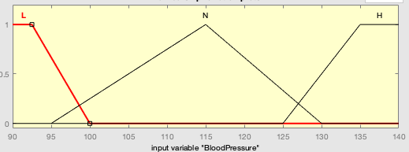

*Fig 6: Membership function for Blood Pressure*

1. Heart Rate

Similar to temperature and blood pressure, Heart rate is also important for analyzing whether a person is ill or not. The input range is considered between 20 to 140 bpm (Beats per Minute) and divided into 5 different membership value ranges as shown below.

|  |  |  |
| --- | --- | --- |
| Membership Function | Range (bpm) | Type |
| VL | 10 to 30 | Trapezoid |
| L | 20 to 70 | Triangle |
| M | 45 to 95 | Triangle |
| H | 70 to 120 | Triangle |
| VH | 100 to 140 | Trapezoid |
| *Table 7: Details of Heart Rate MF* | | |

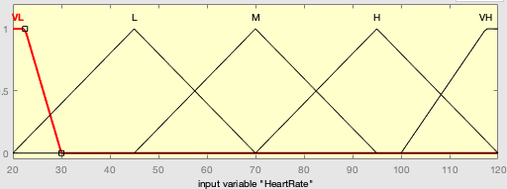

*Fig 7: Membership function for Heart Rate*

1. Human Presence

Human presence is an essential input for identifying whether a person is inside the house and control the devices based on that result. In this course work, considered human presence as input for automatic lamps. If a person is there in room, then only the lamp will be ‘on’ considering the light factor along with.

Presence range is defined in between 0 to 100 % and divided into 3 ranges VL, M and VH as shown below.

|  |  |  |
| --- | --- | --- |
| Membership Function | Range (%) | Type |
| VL | 0 to 40 | Triangle |
| M | 10 to 90 | Triangle |
| VH | 50 to 100 | Triangle |
| *Table 8: Details of Human Presence MF* | | |

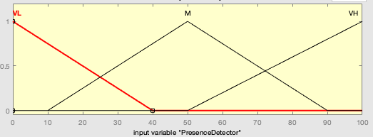

*Fig 8: Membership function for presence detector*

1. Moisture

There are changes that the elderly people keep the water taps on unknowingly for a longer period. Identifying moisture content on the floor and alerting the same is critical to avoid accidents. In this work, considered Moisture as input for water flow detector. The value range considered between 0 to 100% and divided into 5 ranges as shown below.

|  |  |  |
| --- | --- | --- |
| Membership Function | Range (%) | Type |
| VL | 0 to 20 | Trapezoid |
| L | 10 to 50 | Triangle |
| M | 25 to 75 | Triangle |
| H | 50 to 90 | Triangle |
| VH | 80 to 100 | Trapezoid |
| *Table 9: Details of Moisture MF* | | |

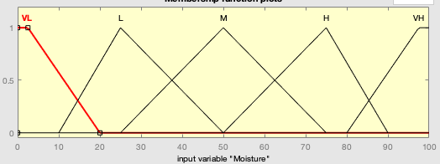

*Fig 9: Membership function for Moisture*

1. Bed Surface Pressure

Bed surface pressure ideally indicate whether someone is laying on the bed or not. It helps in monitoring people who suffer insomnia. In this coursework, considered bed surface pressure as a key input for the bed occupancy detector device. If the person is not in bed for long time or in bed for long time, an alert will be generated. The input values range between 0 to 100% and divided into 5 membership functions.

|  |  |  |
| --- | --- | --- |
| Membership Function | Range (%) | Type |
| VL | 0 to 20 | Trapezoid |
| L | 10 to 50 | Triangle |
| M | 30 to 70 | Triangle |
| H | 60 to 90 | Triangle |
| VH | 80 to 100 | Trapezoid |
| *Table 10: Details of Bed Surface Pressure MF* | | |

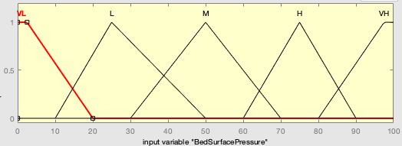

*Fig 10: Membership function for Bed Surface Pressure*

1. Time Delay

Time delay is an import input for Bed Occupancy Detector in this work, as the alert should trigger considering a person’s delay in coming back to bed or getting on from bed. The input restricted into 1 hour. Values range from 0 to 60 minute and divided into 3 membership functions as shown below.

|  |  |  |
| --- | --- | --- |
| Membership Function | Range (minute) | Type |
| L | 0 to 25 | Trapezoid |
| M | 10 to 50 | Triangle |
| H | 30 to 60 | Trapezoid |
| *Table 11: Details of Time Delay MF* | | |

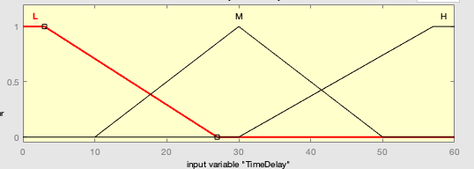

*Fig 11: Membership function for Time Delay*

1. Smoke

Here smoke in general terms considered any form of CO2, CO or any other toxic gases. It is an important input for smoke detector in kitchen. The value range is considered between 0 to 100% and divided into 5 membership functions as shown below.

|  |  |  |
| --- | --- | --- |
| Membership Function | Range (%) | Type |
| VL | 0 to 20 | Trapezoid |
| L | 10 to 50 | Triangle |
| M | 30 to 70 | Triangle |
| H | 60 to 90 | Triangle |
| VH | 80 to 100 | Trapezoid |
| *Table 12: Details of Smoke MF* | | |

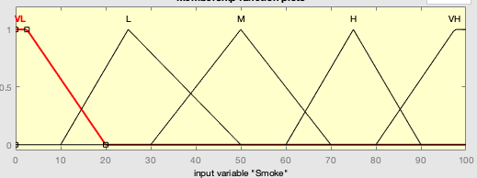

*Fig 12: Membership function for Smoke*

1. Type of Food

Designing a smart oven for kitchen appliance requires the information regarding the type of food that should be heated. The input values range between 0 to 100% and divided into 3 different membership functions like ‘Raw’, ‘Half-Cooked’ and ‘Fully-Cooked’ as shown below.

|  |  |  |
| --- | --- | --- |
| Membership Function | Range (%) | Type |
| Raw | 0 to 40 | Triangle |
| Half-Cooked | 20 to 90 | Triangle |
| Fully-Cooked | 70 to 100 | Triangle |
| *Table 13: Details of Type of Food MF* | | |

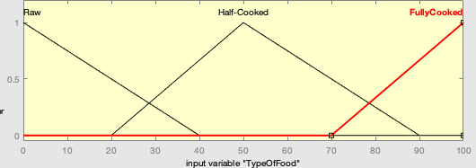

*Fig 13: Membership function for Type of Food*

1. Quantity of Food

Similar to type of food, quantity of food is also an essential input for the smart oven. The value range considered between 0 to 100% and divided into 3 membership functions like ‘Little’, ‘Medium’ and ‘Large’ as shown below.

|  |  |  |
| --- | --- | --- |
| Membership Function | Range (%) | Type |
| Little | 0 to 40 | Triangle |
| Medium | 20 to 90 | Triangle |
| Large | 70 to 100 | Triangle |
| *Table 13: Details of Quantity of Food MF* | | |

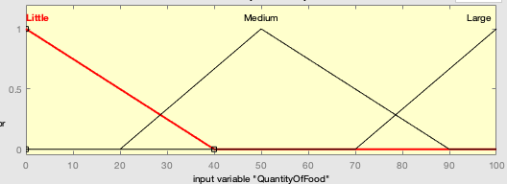

*Fig 13: Membership function for Quantity*

*of Food*

1. Water Temperature

Since water temperature differs with atmospheric temperature, while designing water boiler, considered water temperature as a key input. The input value ranges between 0 to 70 Degree Celsius and divided into 5 different membership functions as shown below.

|  |  |  |
| --- | --- | --- |
| Membership Function | Range (℃) | Type |
| VL | 0 to 15 | Trapezoid |
| L | 10 to 30 | Triangle |
| M | 20 to 50 | Triangle |
| H | 35 to 65 | Triangle |
| VH | 60 to 70 | Trapezoid |
| *Table 15: Details of Water Temperature MF* | | |

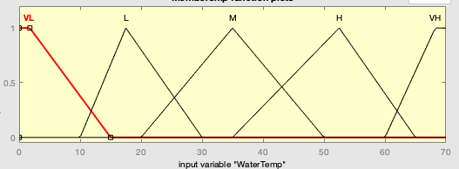

*Fig 15: Membership function for Water Temperature*

1. Surrounding Volume

Adjusting the volume of TV or any other devices like that, automatically is a good help for the elderly or disabled people. In this course work considered Surrounding Volume as input so that based on that the TV volume can be controlled. The value range considered between 0 to 40 decibel and divided into 5 different membership functions as shown below.

|  |  |  |
| --- | --- | --- |
| Membership Function | Range (db) | Type |
| VL | 0 to 8 | Trapezoid |
| L | 5 to 20 | Triangle |
| M | 10 to 30 | Triangle |
| H | 25 to 35 | Triangle |
| VH | 33 to 40 | Trapezoid |
| *Table 16: Details of Surrounding Volume MF* | | |

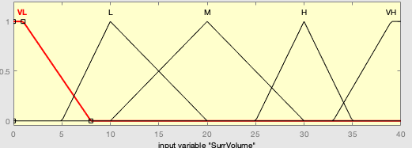

*Fig 16: Membership function for Surrounding Volume*

Once the input variables are created, next step in FIS design is to design output variables and their membership functions. As shown in *table 1* designed 10 different output variables for smart home in this coursework. The output variables can be considered as the smart devices installed in the flat, in a general way.

Output Variables and Membership functions:

1. Heater

Heater is the device which controls the overall temperature of the home based on the room temperature and the humidity. The value range considered in between 0 to 10 as the heater output scale and divided into 5 membership functions (VL, L, M, H and VH) as shown below.

|  |  |  |
| --- | --- | --- |
| Membership Function | Range | Type |
| VL | 0 to 2.5 | Trapezoid |
| L | 1 to 5 | Triangle |
| M | 2.5 to 7.5 | Triangle |
| H | 5 to 8 | Triangle |
| VH | 7 to 10 | Trapezoid |
| *Table 17: Details of Heater MF* | | |

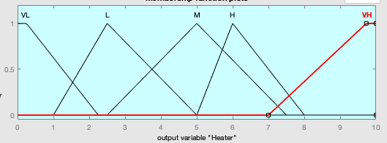

*Fig 17: Membership function for Heater*

1. Automatic Lamp

Switching on and off the lamps automatically, by detecting the presence of a person in a room and the day light available, is always a smart design especially for energy savers. The lamp value ranges between 0 to 20,000 Lux and divided into 5 different membership functions as shown below.

|  |  |  |
| --- | --- | --- |
| Membership Function | Range (Lux) | Type |
| VL | 0 to 4500 | Trapezoid |
| L | 2000 to 8000 | Triangle |
| M | 4500 to 12000 | Triangle |
| H | 10000 to 16000 | Triangle |
| VH | 15500 to 20000 | Trapezoid |
| *Table 18: Details of Automatic Lamp MF* | | |

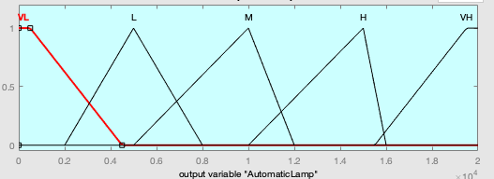

*Fig 18: Membership function for Automatic Lamp*

1. Corporal Detector

Corporal Detector or illness detector can be considered as the most essential device that should be added in elderly support. It will take inputs as body temperature, blood pressure and heart rate and alerts any unusual variations from the normal rage. It helps the carers to identify if the person is ill or not. The detector values range from 0 to 100% and divided into 5 different membership functions as shown below.

|  |  |  |
| --- | --- | --- |
| Membership Function | Range (%) | Type |
| VL | 0 to 20 | Trapezoid |
| L | 10 to 50 | Triangle |
| M | 25 to 75 | Triangle |
| H | 50 to 90 | Triangle |
| VH | 70 to 100 | Trapezoid |
| *Table 19: Details of Corporal Detector MF* | | |

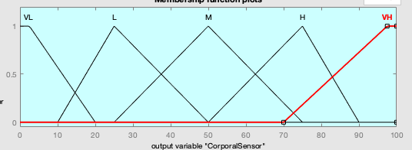

*Fig 19: Membership function for Corporal Detector*

1. Water Flow Detector

Water flow detector can be placed in bathroom or in kitchen. It detects the overflow of water and identifies whether the tap is kept on for longer period or not by detecting the moisture content on the floor. The value range between 0 to 10 and divided into 5 membership functions as shown below.

|  |  |  |
| --- | --- | --- |
| Membership Function | Range | Type |
| VL | 0 to 2 | Trapezoid |
| L | 1 to 5 | Triangle |
| M | 3 to 7 | Triangle |
| H | 5 to 9 | Triangle |
| VH | 8 to 10 | Trapezoid |
| *Table 20: Details of water flow Detector MF* | | |

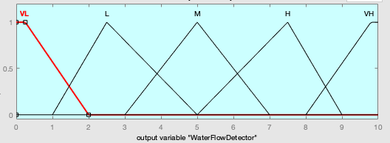

*Fig 20: Membership function for water flow*

*Detector*

1. Bed Occupancy Detector

Bed occupancy detector is a small device, that can be placed below the bedsheet. It allows to identify whether a person is there in bed or not. It’s a key device that can be installed for elderly support as we may alert the carer if the person is not return to bed after a certain period of time or if a person did not get up from bed after a certain amount of time. The value ranges from 0 to 100% and divided into 5 membership functions as shown below.

|  |  |  |
| --- | --- | --- |
| Membership Function | Range (%) | Type |
| VL | 0 to 20 | Trapezoid |
| L | 10 to 50 | Triangle |
| M | 30 to 70 | Triangle |
| H | 60 to 90 | Triangle |
| VH | 80 to 100 | Trapezoid |
| *Table 21: Details of Bed Occupancy Detector MF* | | |

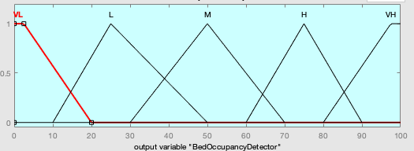

*Fig 21: Membership function for Bed Occupancy Detector*

1. Smoke Detector

Smoke detector detects the presence of smoke content in the surrounding and alerts it. The values range from 0 to 8 and divided into 5 membership functions as shown below.

|  |  |  |
| --- | --- | --- |
| Membership Function | Range | Type |
| VL | 0 to 2 | Trapezoid |
| L | 1 to 3 | Triangle |
| M | 2 to 5 | Triangle |
| H | 4 to 7.5 | Triangle |
| VH | 6.5 to 8 | Trapezoid |
| *Table 22: Details of smoke Detector MF* | | |

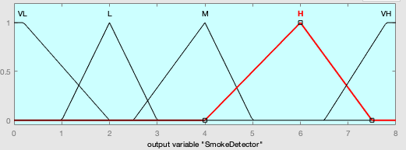

*Fig 22: Membership function for smoke*

*Detector*

1. Water Boiler

Water Boiler is the device to maintain the water temperature in bathroom. It considers the atmospheric temperature and water temperature to decide the water heating rate. Getting hot water for bathroom needs is essential for elderly and disabled population. The output scale range between 0 to 10 and divided into 5 membership functions.

|  |  |  |
| --- | --- | --- |
| Membership Function | Range | Type |
| VL | 0 to 2 | Trapezoid |
| L | 1 to 5 | Triangle |
| M | 3 to 7 | Triangle |
| H | 6 to 9 | Triangle |
| VH | 8 to 10 | Trapezoid |
| *Table 23: Details of Boiler MF* | | |

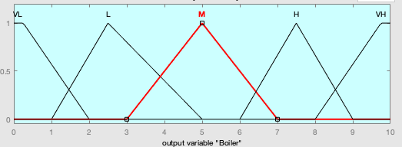

*Fig 23: Membership function for Boiler*

1. Smart Oven

Based on the type of food and quantity of food, the oven deices automatically the time require to heat up the food. The output scale varies between 0 to 60 minutes and divided into 5 different membership functions as shown below.

|  |  |  |
| --- | --- | --- |
| Membership Function | Range (Minute) | Type |
| VL | 0 to 10 | Triangle |
| L | 5 to 20 | Triangle |
| M | 10 to 40 | Triangle |
| H | 20 to 50 | Triangle |
| VH | 40 to 60 | Triangle |
| *Table 24: Details of Oven MF* | | |

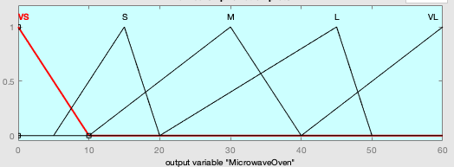

*Fig 24: Membership function for Oven*

1. Automatic Bed Lamp

Automatic Bed lamp turn on when a person gets up from bed in the nighttime. It will be helpful for elderly people especially as it can avoid unnecessary accidents. It considered the bed surface pressure and Light as inputs and turns on accordingly. The values range between 0 to 10000 lux and divided into 5 membership functions.

|  |  |  |
| --- | --- | --- |
| Membership Function | Range (Lux) | Type |
| VL | 0 to 2500 | Trapezoid |
| L | 1000 to 5000 | Triangle |
| M | 2500 to 7500 | Triangle |
| H | 5000 to 9000 | Triangle |
| VH | 7000 to 10000 | Trapezoid |
| *Table 25: Details of Automatic Bed Lamp MF* | | |

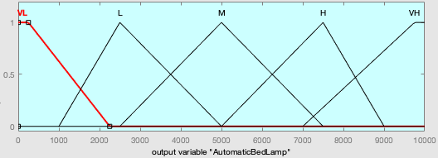

*Fig 25: Membership function for Bed lamp*

1. TV Ear

TV Ear is a smart device which would automatically adjusts the volume of the TV according to the surrounding volume. The output TV volume ranges between 0 to 70 decibel and divided into 5 membership functions.

|  |  |  |
| --- | --- | --- |
| Membership Function | Range (db) | Type |
| VL | 0 to 15 | Trapezoid |
| L | 10 to 30 | Triangle |
| M | 20 to 50 | Triangle |
| H | 40 to 65 | Triangle |
| VH | 55 to 70 | Trapezoid |
| *Table 26: Details of Automatic TV Ear MF* | | |

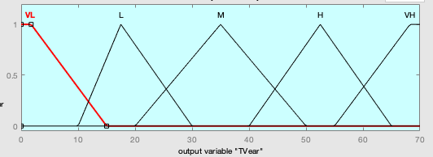

*Fig 26: Membership function for TV Ear*

The FIS Engine:

The main component of a fuzzy control system is it’s FIS engine. It can be called as the brain of the control system. FIS engine maps the inputs to outputs in the form of rules. Well defined rules improve the efficiency of the system. Below is the Mamdani FIS system designed for this coursework.

*Fig 27: FIS system*

Below are the set of rules defined for each output variable and surface plot.

1. Heater

|  |  |  |  |  |  |
| --- | --- | --- | --- | --- | --- |
| Humidity | VL | L | M | H | VH |
| Temperature |  |  |  |  |  |
| VL | VH | VH | H | H | H |
| L | H | H | H | M | M |
| M | M | M | M | M | L |
| H | L | L | L | L | L |
| VH | VL | VL | VL | VL | VL |
| *Table 27: Heater rules* | | | |  |  |

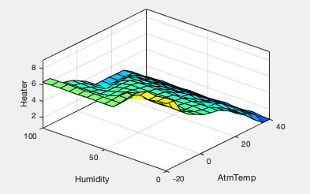

*Fig 28: Temperature, Humidity vs Heater*

1. Automatic Lamp

|  |  |  |  |  |  |
| --- | --- | --- | --- | --- | --- |
| Presence | VL | L | M | H | VH |
| Light |  |  |  |  |  |
| VL | VL | VL | H | VH | VH |
| L | VL | L | H | H | H |
| M | VL | L | H | H | L |
| H | VL | L | M | L | L |
| VH | VL | L | M | VL | VL |
| *Table 28: Automatic Lamp rules* | | | |  |  |

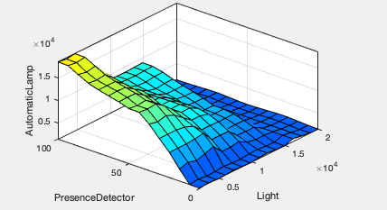

*Fig 29: Light, Human Presence vs Automatic Lamp*

1. Corporal Detector

Here there are 3 inputs in the design, for the visualization simplicity, plotting the output against combination of two inputs.

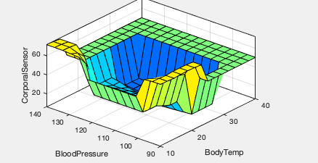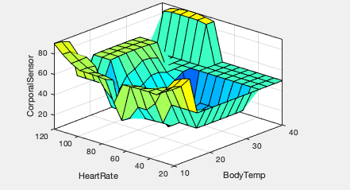

*Fig 30: Blood Pressure, Body Temp vs Corporal Detector Fig 31: Heart rate, Body Temp vs Corporal Detector*

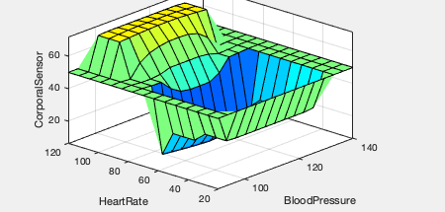 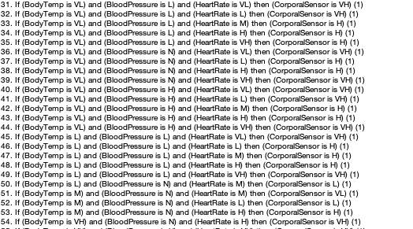

*Fig 32: Blood Pressure, Heart rate vs Corporal Detector Fig 33: Corporal Detector rules*

1. Water Flow Detector

|  |  |  |  |  |  |
| --- | --- | --- | --- | --- | --- |
| Moisture | VL | L | M | H | VH |
| Water Flow Detector | VL | L | M | H | VH |
| *Table 29: Water Flow Detector Rules* | | |  |  |  |

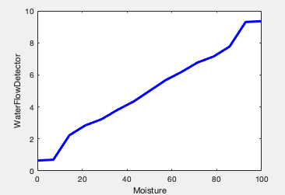

*Fig 34: Moisture vs Water Flow Detector*

1. Bed Occupancy Detector

|  |  |  |  |  |  |
| --- | --- | --- | --- | --- | --- |
| Bed Surface Pressure | VL | L | M | H | VH |
| Time Delay |  |  |  |  |  |
| VL | L | L | M | M | VL |
| L | L | L | M | M | VL |
| M | M | L | L | L | L |
| H | H | H | M | M | L |
| VH | VH | H | H | M | VL |
| *Table 30: Bed Occupancy Detector rules* | | | |  |  |

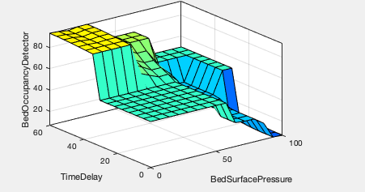

*Fig 35: Bed surface pressure, Time delay vs*

*Bed occupancy detector*

1. Smoke Detector

|  |  |  |  |  |  |
| --- | --- | --- | --- | --- | --- |
| Smoke | VL | L | M | H | VH |
| Smoke Detector | VL | L | M | H | VH |
| *Table 31: Smoke Detector Rules* | | |  |  |  |

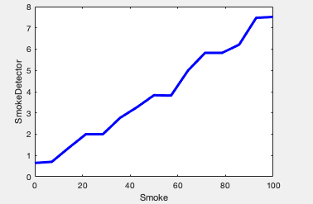

*Fig 36: Smoke vs Smoke Detector*

1. Smart Oven

|  |  |  |  |
| --- | --- | --- | --- |
| Type of Food | Raw | Half-Cooked | Fully-Cooked |
| Quantity of Food |  |  |  |
| Little | VL | L | H |
| Medium | L | M | VH |
| Large | H | H | VH |
| Table 32: Oven Rules | | |  |

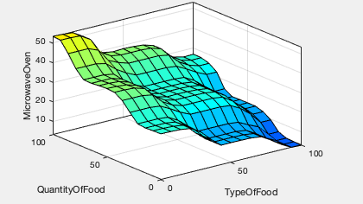

*Fig 37: Type of Food, Quantity vs Oven*

1. Water Boiler

|  |  |  |  |  |  |
| --- | --- | --- | --- | --- | --- |
| Room Temp | VL | L | M | H | VH |
| Water Temp |  |  |  |  |  |
| VL | VH | VH | H | H | M |
| L | VH | H | M | M | L |
| M | H | H | M | L | L |
| H | L | L | L | L | L |
| VH | VL | VL | VL | VL | VL |
| *Table 33: Boiler rules* | | | |  |  |

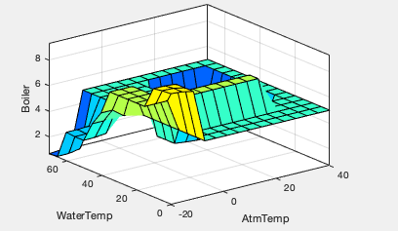

*Fig 38: Room Temp, Water Temp vs Boiler*

1. Automatic Bed Lamp

|  |  |  |  |  |  |
| --- | --- | --- | --- | --- | --- |
| Light | VL | L | M | H | VH |
| Bed Surface Pressure |  |  |  |  |  |
| VL | VH | H | M | L | VL |
| L | VH | H | M | M | L |
| M | H | M | M | L | L |
| H | L | L | L | L | L |
| VH | VL | VL | VL | VL | VL |
| *Table 34: Automatic Bed Lamp rules* | | | |  |  |

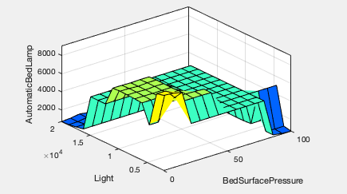

*Fig 39: Light, Bed Surface Pressure vs Bed Lamp*

1. TV Ear

|  |  |  |  |  |  |
| --- | --- | --- | --- | --- | --- |
| Surrounding Volume | VL | L | M | H | VH |
| TV Ear | VL | L | M | H | VH |
| *Table 35: TV Ear Rules* | | |  |  |  |

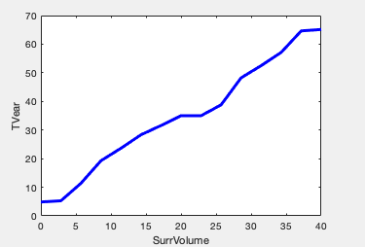

*Fig 40: Surrounding Volume vs TV Ear*

Overall, there defined 118 rules for this system. Once the rules are clearly defined in the FIS system, rules would be get aggregated for the prefect results. The weight for each rule is considered 1 in this work. An overview of rules can be shown in the below figure.

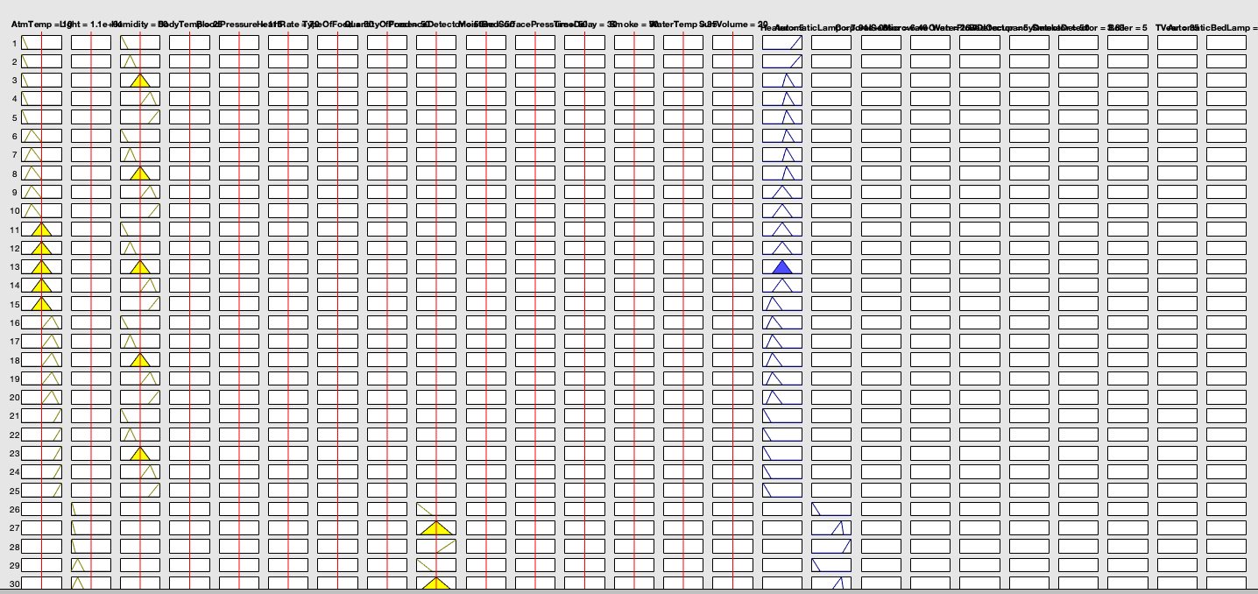

*Fig 41: Aggregated rules*

Part 2 – Optimization of the FLC

Evolutionary Computing is a method to simulate effective optimization algorithms. Optimization improves the quality of solutions in multiple iterations. There are multiple evolutionary computing methods are available. Genetic Algorithm is the popular one among them. In this coursework, considering genetic algorithm techniques to improve the results of fuzzy control system developed in part 1.

Genetic algorithms are inspired from natural selection and genetics. Below are the steps to follow to implement genetic algorithm on a problem.

1. Represent the problem variables as a string of bits called Chromosomes
2. Define a fitness function to evaluate the chromosome performance
3. Construct genetic operators like selection, cross-over and mutation
4. Run GA iteratively and tune the parameters

Considering only four input variables (room temperature, humidity, light and moisture) and three output variables (Heater, Automatic lamp and Boiler) for the further explanation of the process in more simple way. In order to optimize the problem, variables need to be converted into its binary form. Most of the input variables defined as 5 membership functions like VL, L, M, H and VH. In that VL and VH are trapezoidal functions and others are triangular. Trapezoidal functions will have 4 parameters and triangular have 3 parameters. So, for single input 4+3+3+3+4 parameters will be there. For example,

the room temperature input variable can be represented as chromosome in the below shown way.



And the heater output can be represented as



Since the light variable value range till 20000, we would need 16-digit representation. Similarly, to represent -ve values as signed numbers also we would need 16-digit representation. So, the length of the chromosome should be 16. In the above example each cell value represents a chromosome, each single digit in the chromosome represents a gene and the entire chromosome list is known as population.

Once the initial population is represented in terms of chromosomes, need to define a fitness function which should be optimized using the algorithms. Fitness function can be defined based on the input and output relationship in the population. For example, in this coursework sample, heater is represented in terms of room temperature and humidity. So, a sample equation can be derived out from their relations as

Heater = 20* temperature + 10*Humidity^2 + 50.

If we represent this in terms of x and y for all the inputs and outputs, a sample fitness function would look like

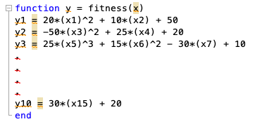

Where y1, y2, ..., y10 are the ten output variables and x1, x2, …, x15 are the input variables.

Once the fitness function is defined, next step is to apply genetic operators on the population.

Selection:

In the selection step, need to select two parents for reproduction based on their fitness value. Selection can be done by multiple methods like roulette wheel selection, ranking selection etc. Let’s consider

|  |  |
| --- | --- |
| x1 | x2 |
| 11111111 11101100 | 11111111 11101110 |

as the parents from the population of the FLC.

Cross-Over:

The crossover operator chooses a random point where the parent chromosomes would get break and exchange the parts after that break. Thus generates two new offsprings.

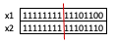

New offsprings would be like below

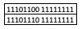

Mutation:

Mutation operator flips a random gene in a chromosome and generates a new chromosome. It ensures that the algorithm is not stuck on a local minimum. Below is an example of mutated input chromosome from the FLC population.

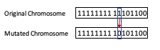

Need to run the GA iteratively multiple times until the offspring population equal to the initial population. Once its equal then consider offspring population as the initial population and run the algorithm again. Parameters like mutation rate, crossover rate and number of generations can be varied and check for best results.

Difference between Mamdani and Sugeno systems:

In this coursework have designed a Mamdani system. If would have designed Sugeno system, then there would not be any membership functions for the output variables. In fact, Sugenno ideally follows MISO (Multiple input single output) system [10]. There is no defuzzification in Sugeno model, it uses weighted average to compute the crisp output. That’s why the computation time is less in the case of Sugeno. Sugeno is more flexible than Mamdani system as it can be integrated more easily with optimization tools to get better outputs. The computational efficiency and adaptiveness to optimization tools makes the Sugeno system more attractive in non-linear dynamic systems [11]. But the interpretability of Mamdani output is lost in Sugeno systems since the consequents of the rules are not fuzzy [11].

Part 3 - Optimization Techniques on CEC’2005 Functions

In this part comparing optimization techniques on CEC’s 2005 functions.

CEC’s 2005 Functions:

There are 25 benchmark functions are available in CEC’s 2005 list. These benchmark functions are ideally standard test problems for testing the performance of optimization techniques developed recently [6]. In this coursework, considered two of the popular basic benchmark functions, ‘Shifted Rotated Rastrigin’s Function’ and ‘Shifted Rotated Weierstrass Function’ for testing the optimization techniques Particle Swarm and Genetic Algorithm.

Shifted Rotated Rastrigin’s Function:

Definition of Shifted Rotated Rastrigin’s Function is shown below

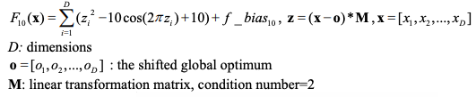

*------source [6]*

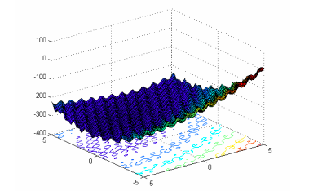

*------source [6]*

Shifted Rotated Weierstrass Function:

Definition of the function is shown below

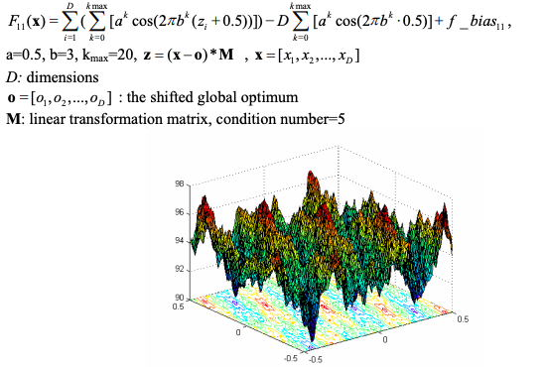

*------source [6]*

Optimization Algorithms:

1. Particle Swarm

Particle Swarm is a bio-inspired simple algorithm which is used to find minimum/maximum of a function defined in a multidimensional space [7]. To apply this algorithm, only the objective function is required. No need of its gradient or differential forms [7]. In this course work, applied particle swarm on above mentioned two benchmark algorithms with D=2 and D=10 for 15 iterations. Results are shown below.

For D = 2

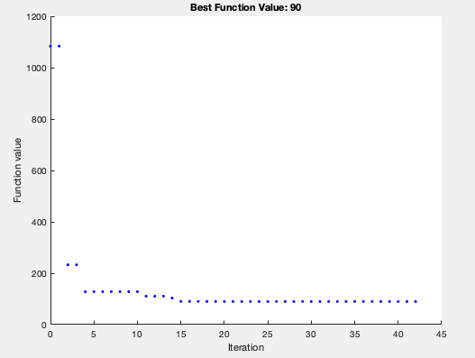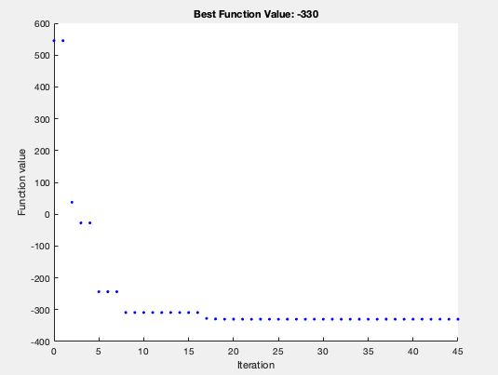

*Fig 42: Shifted Rotated Weierstrass Function Fig 43:* Shifted Rotated Rastrigin’s Function

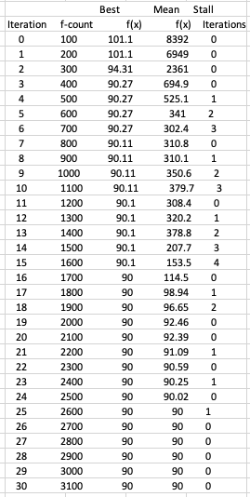 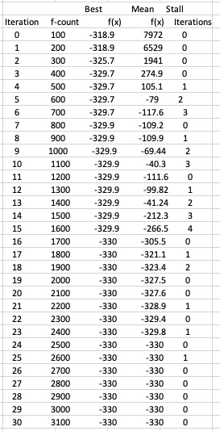

*Fig 44: Shifted Rotated Weierstrass Function results Fig 45: Shifted Rotated Rastrigin’s Function* *results*

For D = 10

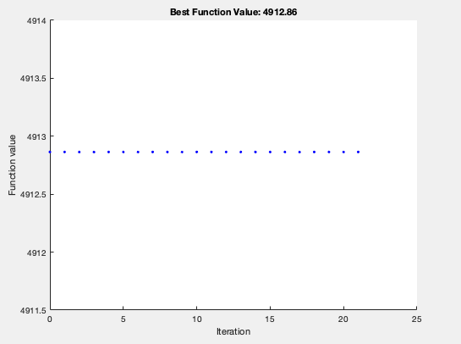 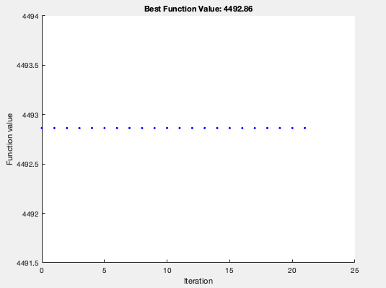

*Fig 46: Shifted Rotated Weierstrass Function Fig 47: Shifted Rotated Rastrigin’s Function*

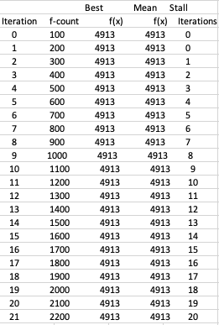 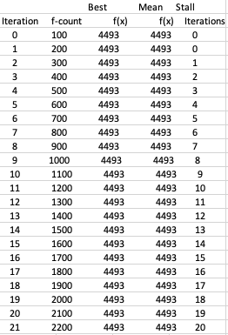

*Fig 48: Shifted Rotated Weierstrass Function results. Fig 49: Shifted Rotated Rastrigin’s Function results*

1. Genetic Algorithm

Genetic Algorithm is one of the most popular optimization technique so far available. The main concept and steps involved of the algorithm is detailed in part 2 of this coursework. Genetic algorithm also applied for the above-mentioned benchmark functions for D=2 and D=10 for 15 iterations. Results are shown below.

|  |  |  |
| --- | --- | --- |
| Iteration | Value (D=2) | Value (D=10) |
| 1 | 90.00271478 | 4912.863702 |
| 2 | 90.02455123 | 4912.863702 |
| 3 | 90.05283853 | 4912.863702 |
| 4 | 90.00147853 | 4912.863702 |
| 5 | 90.00422676 | 4912.863702 |
| 6 | 90.02366573 | 4912.863702 |
| 7 | 90.00939965 | 4912.863702 |
| 8 | 90.00317773 | 4912.863702 |
| 9 | 90.00209842 | 4912.863702 |
| 10 | 90.00095416 | 4912.863702 |
| 11 | 90.00651915 | 4912.863702 |
| 12 | 90.02412548 | 4912.863702 |
| 13 | 90.01362446 | 4912.863702 |
| 14 | 90.00065329 | 4912.863702 |
| 15 | 90.00028968 | 4912.863702 |
| Min | 90.0003 | 4912.863702 |
| Max | 90.0528 | 4912.863702 |
| Mean | 90.0114 | 4912.863702 |
| Std | 0.0145 | 9.41416E-13 |
| *table 36: Shifted Rotated Weierstrass Function values* | | |

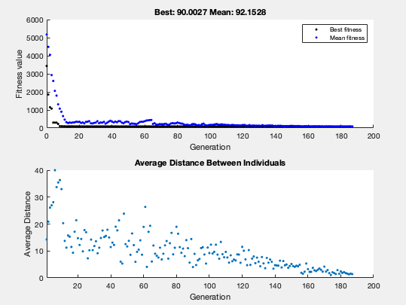

*Fig 50: Shifted Rotated Weierstrass Function D =2*

*Fig 51: Shifted Rotated Weierstrass Function D =10*

|  |  |  |
| --- | --- | --- |
| Iteration | Value (D=2) | Value (D=10) |
| 1 | -329.84771 | 4492.8637 |
| 2 | -329.89984 | 4492.8637 |
| 3 | -329.9816 | 4492.8637 |
| 4 | -329.96062 | 4492.8637 |
| 5 | -329.99456 | 4492.8637 |
| 6 | -329.99559 | 4492.8637 |
| 7 | -329.96463 | 4492.8637 |
| 8 | -329.89216 | 4492.8637 |
| 9 | -329.98834 | 4492.8637 |
| 10 | -329.99627 | 4492.8637 |
| 11 | -329.98335 | 4492.8637 |
| 12 | -329.97612 | 4492.8637 |
| 13 | -329.99975 | 4492.8637 |
| 14 | -329.99147 | 4492.8637 |
| 15 | -329.99715 | 4492.8637 |
| Min | -329.99975 | 4.49E+03 |
| Max | -329.85 | 4.49E+03 |
| Mean | -329.96 | 4.49E+03 |
| Std | 0.04654867 | 0.00E+00 |
| *table 37:*  *Shifted Rotated Rastrigin’s* *Function values* | | |

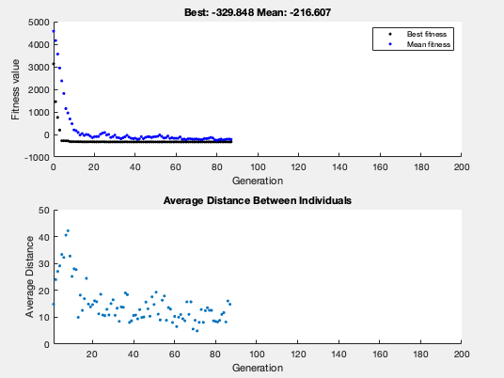

*Fig 52:* Shifted Rotated Rastrigin’s Function D = 2

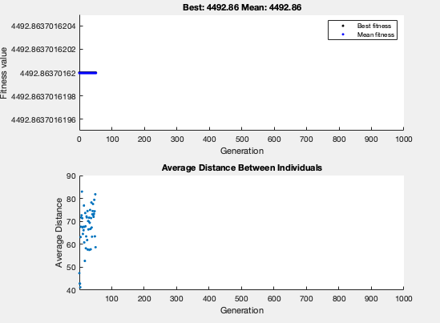

*Fig 52:* Shifted Rotated Rastrigin’s Function D = 10

Conclusion:

In conclusion, both the optimization techniques worked well on both the benchmark functions. From the results, we may see that Particle Swarm convergences into minimum values in lesser iterations when compared to the Genetic Algorithm for D=2. In the case of higher dimension, the values seem to be constant from the 0th iteration itself. Overall, both the techniques succeeded in minimizing the values.

References:

1. Christensen K, Doblhammer G, Rau R, Vaupel JW. Ageing populations: the challenges ahead. Lancet. 2009;374(9696):1196-1208. doi:10.1016/S0140-6736(09)61460-4
2. Health Europa, Research and Innovation news, March 2020
3. J. Lloret, A. Canovas, S. Sendra and L. Parra, "A smart communication architecture for ambient assisted living," in *IEEE Communications Magazine*, vol. 53, no. 1, pp. 26-33, January 2015, doi: 10.1109/MCOM.2015.7010512.
4. Hájek, Petr (1998). *Metamathematics of fuzzy logic* (4 ed.). Springer Science & Business Media
5. Whig P, Ahmad SN (2017) Controlling the Output Error for Photo Catalytic Sensor (PCS) Using Fuzzy Logic. J Earth Sci Clim Change 8:394. doi:10.4172/2157-7617.1000394
6. P. N. Suganthan, N. Hansen, J. J. Liang, K. Deb, Y. -P. Chen, A. Auger, S. Tiwari, ‘Problem Definitions and Evaluation Criteria for the CEC 2005 Special Session on Real-Parameter Optimization’, Technical Report, Nanyang Technological University, Singapore and KanGAL Report Number 2005005 (Kanpur Genetic Algorithms Laboratory, IIT Kanpur), May 2005
7. Andrian Tam, A Gentle Introduction to Particle Swarm Optimization, Machine Learning Mastery, Sep 2021
8. Alessandro Ghelli, Hani Hagras, Ghadah Aldabbagh, A Fuzzy Logic Based Retrofit System for Enabling Smart Energy Efficient Electric Cookers, DOI: [10.1109/TFUZZ.2015.2394781](http://dx.doi.org/10.1109/TFUZZ.2015.2394781), Jan 2015
9. N Deborah Lynn, A I Sourav, A J Santoso, A Fuzzy Logic-based Control System for Microwave Ovens, doi:10.1088/1742-6596/1577/1/012021, Jan 2020
10. Visalini Kumaraswamy (https://math.stackexchange.com/users/574038/visalini-kumaraswamy), What is the difference between mamdani and sugeno in fuzzy logic?, URL (version: 2018-07-04): <https://math.stackexchange.com/q/2840703>
11. Arshdeep Kaur, Amrit Kaur, Comparison of Mamdani-Type and Sugeno-Type Fuzzy Inference Systems for Air Conditioning System, International Journal of Soft Computing and Engineering (IJSCE) ISSN: 2231-2307, Volume-2, Issue-2, May 2012

Appendix:

The FIS file : <https://github.com/Umadeviak/7135CEM-Coursework-SourceCode>

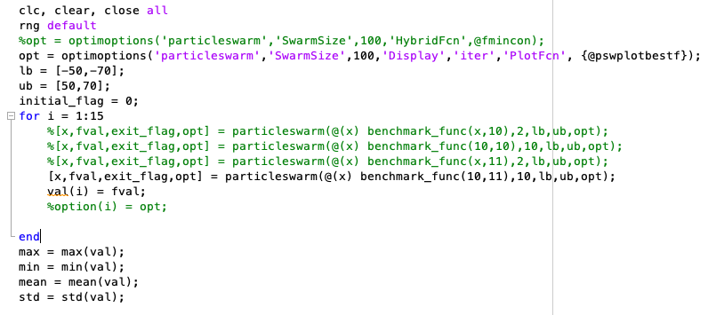

*Particle Swarm application matlab code*

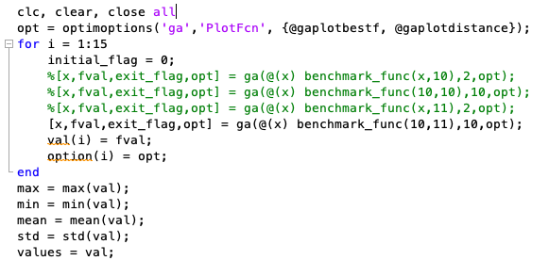

*Genetic Algorithm application matlab code*